 | FOR IMMEDIATE RELEASE  Contact: Steve Hollinger  Phone: 617 338-2222  steve @ kayalu.com  Press release PDF and high-res images  available at https://www.kayalu.com/press  Kayalu INTRODUCES WATERTORCH™ XT  KAYAK and STAND-UP PADDLEBOARD LIGHT WITH POWER-LOCKING SUCTION CUP |  | 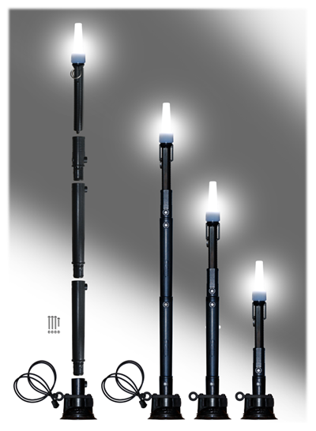
(Boston, MA — April 15, 2022) Kayalu is now shipping the WaterTorch XT, a bright white, 360°, dual-LED navigation light with a “power-locking” suction cup, intended for use on all U.S. Coast Guard classified “vessels under oars” including kayaks, sit-on-tops, stand-up paddleboards, canoes, dinghies and rowboats.

The WaterTorch XT ships as a kit capable of being user-assembled to a height of 13.5" (34 cm), 20.5" (52 cm) and 27.5" (72 cm). Minor assembly is required.

“Responding to a number of challenges, the WaterTorch XT uniquely provides a user-selectable height and reliably strong mounting solution,” said Kayalu founder Steve Hollinger. “Incorporating many features of our top-selling Kayalite® kayak light, the WaterTorch XT is also submersible and virtually indestructible.”

The WaterTorch XT incorporates a mechanical suction cup manufactured by RAM Mounting Systems (Seattle, WA), renown for premium quality mounting solutions. The RAM “power-locking” suction cup, compatible with all relatively flat, smooth, non-porous materials and surfaces, enables its user to position the WaterTorch XT on the deck and, with a twist, to leverage a powerful vacuum. Kayalu is an Authorized RAM Mounts Partner.
The WaterTorch XT includes bright white dual-LED light manufactured by Tektite Industries (Trenton, NJ), featuring a 10,000-hour lamp life, operable for 100 hours on three AA batteries (included). The WaterTorch XT is constructed of impact-resistant 1/8" wall ABS and Lexan, with marine-grade stainless steel bolts and locknuts. Rubber o-rings at each joint manage expansion and contraction anticipated in harsh environmental conditions, from sunlight to icewater.

The WaterTorch XT is submersible to 1,000 feet (300m) below sea level (IPX8 rated). All components are manufactured of materials resistant to corrosion in saltwater or freshwater.

The WaterTorch XT meets U.S.C.G. Rule 25 and Safety of Life at Sea (SOLAS) regulations for use on a kayak, SUP, SOT, canoe, dinghy and other U.S.C.G. classified vessels under oars.

The WaterTorch XT is Made in USA, available from Kayalu and authorized dealers at a suggested retail price of $79.95.

###

Kayalu is the outdoor products division of S. H. Pierce & Co. (Boston, MA), a product developer and engineering company founded in 1989. WaterTorch, Kayalite, Secure-Attach and the Kayalu logo are trademarks and registered trademarks of Kayalu.

